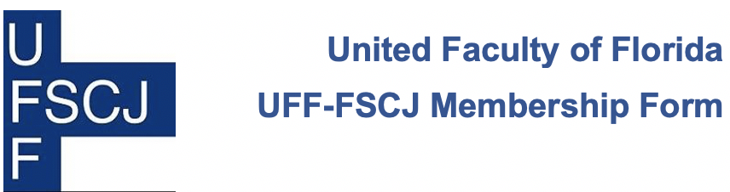

YES [ ] I want to join my colleagues by becoming a member of the United Faculty of Florida, NEA, AFT, FEA, AFL-CIO, and my local UFF chapter. I hereby request and voluntarily accept membership in the United Faculty of Florida, NEA, AFT, FEA, AFL-CIO, and my local UFF chapter, and agree to abide by the Constitution and Bylaws of all organizations.

________________________________ ________________________________
Last Name, First Name Department or Unit
________________________________ ________________________________
Home Street Address Campus Address & Mail Code
________________________________ ________________________________
City State Zip Code Home Phone Office Phone
________________________________ ________________________________
Personal Email Address FSCJ Email Address
____________________________
Last 4 digits of your Social Security Number

YES [ ] I authorize payment by Florida State College at Jacksonville to deduct from my pay in each pay period a pro-rata portion of the annual dues. Annual dues are one percent of my regular salary and include all fees and assessments required for membership in the United Faculty of Florida, NEA, AFT, FEA, AFL-CIO, and my local UFF chapter. This authorization continues annually regardless of my membership status, unless (a) I revoke this authorization upon 30 days’ notice in writing sent via email, fax or US mail to the employer and employee organization according to Florida Statue 447.303, or (b) my employment with Florida State College at Jacksonville ends.

I UNDERSTAND THAT THIS AGREEMENT IS VOLUNTARY AND IS NOT A CONDITION OF EMPLOYMENT, AND THAT I HAVE THE LEGAL RIGHT TO REFUSE TO SIGN THIS AGREEMENT WITHOUT SUFFERING ANY REPRISAL.

________________________________________ ______________________
Signature (for payroll deduction authorization) Today’s date

Return this form to Dr. Maureen A. McCormick, Florida State College at Jacksonville, Deerwood Center, C2316, mmccormi@fscj.edu.
This Photo by Unknown Author is licensed under CC BY-SA | “I consider it important, indeed urgently necessary, for intellectual workers to get together, both to protect their own economic status and, also generally, to secure their influence in the political field.” Albert Einstein, charter member, AFT, Princeton, 1938.

UFF-FSCJ: Things to Know

UFF-FSCJ negotiates the contract on behalf of all faculty at FSCJ. We strive for equitable salaries for our faculty and safeguard academic freedom. UFF provides its members with:

- Assistance and representation when meeting with administrators
- Grievance support and representation
- Legal representation
- Membership in state and national education associations (FEA, NEA, AFT)
- A voice in Tallahassee that advocates the interests of faculty and students before the Florida Legislature and education agencies
- A professional network that includes faculty at

Broward College
Chipola State College
College of the Florida Keys
Eastern Florida State College
Florida Agricultural and Mechanical University
Florida Atlantic University
Florida Gulf Coast University
Florida International University
Florida Polytechnic University
Florida Southwestern State College
Florida State University
Hillsborough Community College
Lake Sumter State College
New College of Florida
Palm Beach State College
Pasco Hernando State College
Pensacola State College
Saint Leo University
Saint Johns River State College
Seminole State College
State College of Florida
Tallahassee Community College
University of Central Florida
University of Florida
University of North Florida
University of South Florida
University of West Florida
… and the graduate assistants at Florida Agricultural and Mechanical University, Florida State University, University of Florida, & University of South Florida

UFF-FSCJ provides grievance representation for its members; UFF does not provide grievance representation to faculty who were not dues-paying UFF members at the time when the grievable incident occurred.
Membership in UFF-FSCJ is open to all full-time faculty at Florida State College at Jacksonville but you are not automatically enrolled. You must complete and sign this membership form and submit it to UFF-FSCJ in order to become a member. Not sure if you are already a member? Contact Dr. Maureen McCormick (mmccormi@fscj.edu) to verify whether you are a member.

